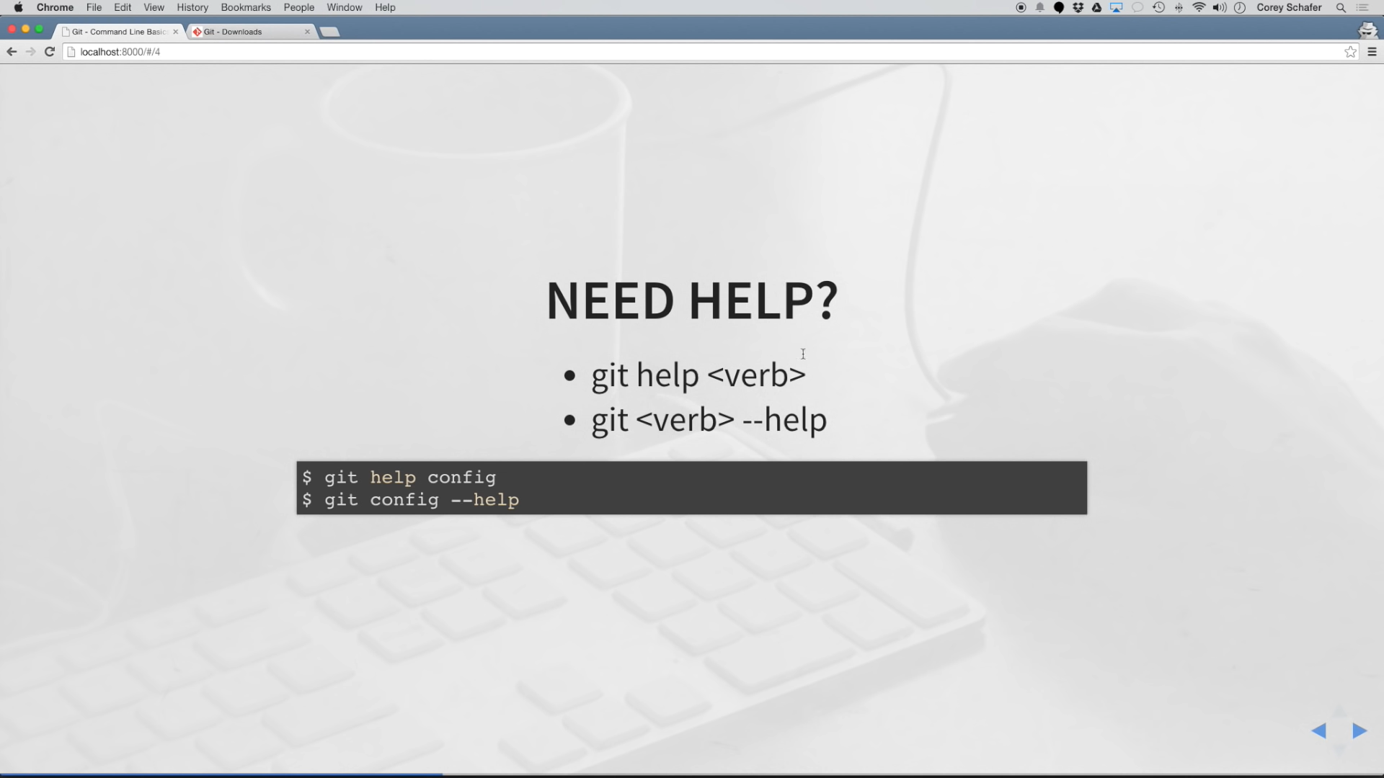

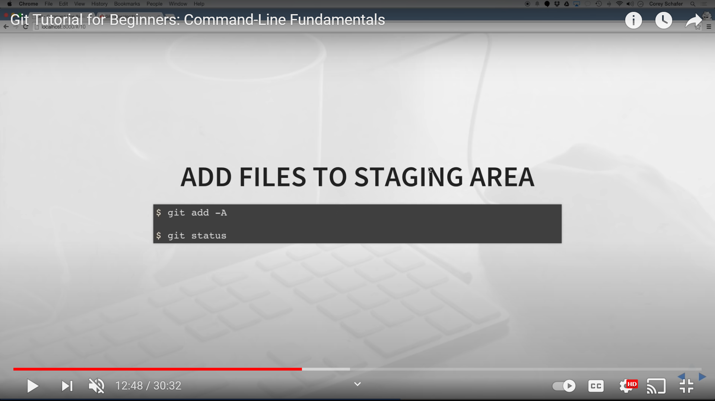

Diff – showing the changes those have been made.

